**THE PATTERNS COMPANY**

4th Floor, Bizness Square Junction Opposite Hitex Road, HITEC City, Madhapur, Hyderabad, Telangana 500084

+91-8500693113

+91-9392744210

[info@thepatternscompany.com](mailto:info@thepatternscompany.com)

https://[www.thepatternscompany.com/](http://www.thepatternscompany.com/)





Website Report for neweradiagnostics.in

# This report grades your website based on the strength of various SEO factors such as On Page Optimization, O Page Links, Social and more. The overall Grade is on a A+ to F- scale, with most major, industry leading websites in the A range. Improving your grade will generally make your website perform better for users and rank better in search engines. There are recommendations for improving your website at the bottom of the report. Feel free to reach out to us if you’d like us to help with improving your website’s SEO!

Audit Results for neweradiagnostics.in



**D**

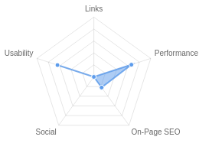**Your page could be better**

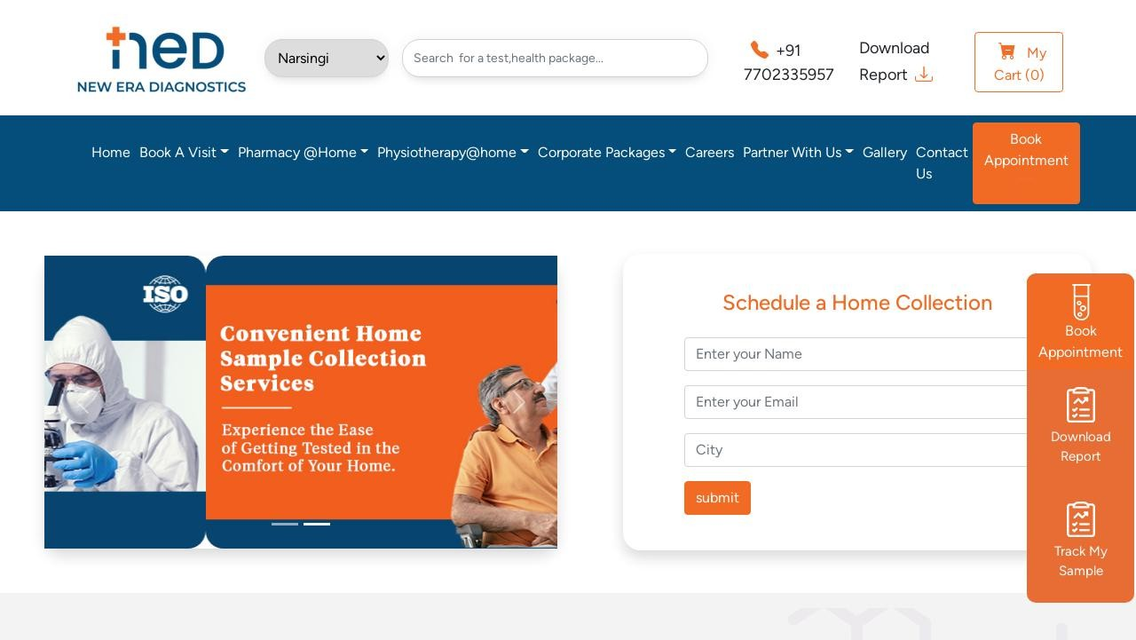

Recommendations: 26



**D-**



**F**



**B**



**B+**



**F**

On-Page SEO

Links

Usability

Performance

Social

Recommendations

**Execute a Link Building Strategy**

Links

High Priority

**Include a meta description tag**

On-Page SEO

High Priority

**Implement a redirect to HTTPS on your website**

On-Page SEO

Medium Priority

|  |  |  |
| --- | --- | --- |
| **Implement a XML sitemaps file** | On-Page SEO | Medium Priority |
|  |  |  |
| **Implement a robots.txt file** | On-Page SEO | Medium Priority |
|  |  |  |
| **Add Canonical Tag** | On-Page SEO | Medium Priority |
|  |  |  |
| **Remove Duplicate H1 Tags** | On-Page SEO | Medium Priority |
| **Update Link URLs to be more human and Search Engine readable** | Links | Low Priority |
| **Add Alt attributes to all images** | On-Page SEO | Low Priority |
| **Create and link your Facebook Page** | Social | Low Priority |
| **Create and link your Twitter profile** | Social | Low Priority |
| **Increase page text content** | On-Page SEO | Low Priority |
|  |  |  |
| **Make use of HTTP/2+ protocol** | Performance | Low Priority |
|  |  |  |
| **Optimize your images to reduce their file size** | Performance | Low Priority |
| **Optimize your page for Mobile PageSpeed Insights** | Usability | Low Priority |
| **Implement an analytics tracking tool** | On-Page SEO | Low Priority |
|  |  |  |
| **Add Schema Markup** | On-Page SEO | Low Priority |
| **Please add Facebook Open Graph Tags** | Social | Low Priority |
| **Add Twitter Cards** | Social | Low Priority |
| **Create and link associated Instagram profile** | Social | Low Priority |
| **Create and link an associated YouTube channel** | Social | Low Priority |

|  |  |  |
| --- | --- | --- |
| **Create and link an associated LinkedIn profile** | Social | Low Priority |
| **Setup & Install a Facebook Pixel** | Social | Low Priority |
| **Remove clear text Email Addresses** | Usability | Low Priority |
| **Add Local Business Schema** | Other | Low Priority |
| **Improve Google Business Profile Rating & Review Count** | Other | Low Priority |

On-Page SEO Results

**Your On-Page SEO needs improvement**

Your page is not well optimized from an On-Page SEO perspective. On-Page SEO is important to ensure Search Engines can understand your content appropriately and help it rank for relevant keywords. You should ensure that HTML Tag Content is completed correctly and align text content to target keywords.



**D-**

## Title Tag

You have a title tag of optimal length (between 10 and 70 characters). New Era Diagnostics

Length : 19

## Meta Description Tag

Your page appears to be missing a meta description tag.

A meta description is important for search engines to understand the content of your page, and is often shown as the description text blurb in search results.

## SERP Snippet Preview

This illustrates how your page may appear in Search Results. Note, this is intended as a guide and Search Engines are more frequently generating this content dynamically.

[http://neweradiagnostics.in](http://neweradiagnostics.in/)

New Era Diagnostics

## Hreflang Usage

Your page is not making use of Hre ang attributes.

## Language

Your page is using the lang attribute. Declared: English

## H1 Header Tag Usage

Your page has more than one H1 Tag. It is generally recommended to only use one H1 Tag on a page.

The H1 Header Tag is an important way of signaling to search engines what your content is about, and subsequently the keywords it should rank for.

## H2-H6 Header Tag Usage

Your page is making use multiple levels of Header Tags.

Header Tag Frequency

H3

0

H5

3

H6 0

H4 1

H2 16

## Keyword Consistency

Your page's main keywords are distributed well across the important HTML tags.

Individual Keywords

Keyword Title Meta Description

Tag

Headings Tags Page Frequency

diagnostics

✓



✓

6

lab





✓

5

healthcare





✓

4

report







3

book    4

packages    5

new    6

era    6

Phrases

Phrase Title Meta Description

Tag

Headings Tags Page Frequency

era diagnostics

✓



✓

5

download report







3

lab we







2

book appointment    2

new era diagnostics    5

new era    6

## Amount of Content

Your page has a low volume of text content which search engines can interpret as 'thin content'. Word Count: 398

It has been well researched that higher text content volumes are related to better ranking ability in

general.

## Image Alt Attributes

You have images on your page that are missing Alt attributes.

We found 17 images on your page and 15 of them are missing the attribute.

Alt attributes are an often overlooked and simple way to signal to Search Engines what an image is about, and help it rank in image search results.

## Canonical Tag

Your page is not using the Canonical Tag.

The Canonical Tag tells Search Engines the primary URL of a page. Google recommends all pages specify a Canonical.

## Noindex Tag Test

Your page is not using the Noindex Tag which prevents indexing.

## Noindex Header Test

Your page is not using the Noindex Header which prevents indexing.

## SSL Enabled

Your website has SSL enabled.

## HTTPS Redirect

Your page does not redirect to a HTTPS (SSL secure) version.

## Robots.txt

We have not detected or been able to retrieve a robots.txt le successfully.

A robots.txt le is recommended as it can provide important instructions to a search engine for how to most appropriately crawl your website as well as site areas that should be ignored.

## Blocked by Robots.txt

Your page does not appear to be blocked by robots.txt.

## XML Sitemaps

We have not detected or been able to retrieve a XML sitemaps le successfully.

Sitemaps are recommended to ensure that search engines can intelligently crawl all of your pages.

## Analytics

We could not detect an analytics tool installed on your page.

Website analytics tools like Google Analytics assist you in measuring, analyzing and ultimately improving tra c to your page.

## Schema.org Structured Data

We have not detected any usage of Schema.org on your page.

Schema.org is a structured data markup for webpages which helps Search Engines understand your site better and provide rich snippets directly in their search results.

Rankings

## Top Keyword Rankings

This shows your top 10 Keyword Rankings in the speci c location. The list is ordered by the keywords that drive the most tra c to your page.

Keyword Country & Language

Position Total

Searches

Estimated Tra c



telangana diagnostics

report download

HI

93

590

1

telangana diagnostics

report download

EN

79

590

1

newera hospital photos

EN

87

260

0

new era lab EN 92 30 0

new era hospital EN 56 2,400 5

new era labs  EN 58 30 0

## Total Traffic From Search

This shows you the Estimated Tra c Volume your page receives from it’s Keyword Rankings



8

Monthly Tra c

Volume

## Keyword Positions

This shows you a summary of the positions for your Keyword Rankings. The higher you rank, the more likely you are to capture tra c, with recent research showing that as much as 92% of clicks happen on the rst page.

Position Keywords

Position 2-3

0

Position 11-20

0

Position 31-100

6

Position 21-30 0

Position 4-10 0

Position 1 0

Links

## Backlink Summary

You have a reasonably weak level of backlink activity to this page.

Search Engines use backlinks as a strong indicator of a page's authority, relevance and ranking potential. There are various strategies available to gain links to a page to improve this factor



**11**



**3**

Domain Strength

Page Strength



**386**

Referring Domains

**445**

Backlinks

|  |  |  |  |  |  |
| --- | --- | --- | --- | --- | --- |
| **138**  Nofollow Backlinks | **307**  Dofollow Backlinks | **0**  Edu Backlinks | **0**  Gov Backlinks | **25**  Subnets | **28**  IPs |

## Top Backlinks

These are the highest value external pages we have found linking to your site.

Domain strength

Referring Page URL

75

<http://blogby-vlog.59bloggers.com/15594125/don-t-fall-to-best-diagnostic-center-in-hyderabad-bl>

indly-read-this-article

75

https://bivap-pro le.blog2learn.com/59721997/the-must-know-details-and-updates-on-health-tes

ts-at-home-hyderabad

75

<http://ensearch-post.tinyblogging.com/Why-Health-Tests-At-Home-Hyderabad-is-a-Trending-Topi>

c-Now--53705383

77

https://[www.linkcentre.com/business/healthcare/medical-testing/20/](http://www.linkcentre.com/business/healthcare/medical-testing/20/)

75

<http://retailring-page.ampblogs.com/New-Era-Diagnostics-Knowing-The-Best-For-You-48059689>

75

https://buypro-microblog.blog2learn.com/59720784/social-network-trending-updates-on-best-lab

-test-center-in-hyderabd

75

<http://elmarket-index.targetblogs.com/16997855/the-qualities-of-an-ideal-best-diagnostic-center->

in-hyderabad

75 https://dealer-journal.blog2learn.com/59720086/latest-news-on-best-lab-services-in-hyderabad

84 https://tu classi ed.com/new-era-diagnostics-all-your-health-checks_1954871

74 <http://resellon-journal.bloggosite.com/16846691/readers-views-point-on-health-tests-at-home-hy> derabad-and-why-it-is-trending-on-social-media

## Top Pages by Backlinks

These are the pages on your site with the most the backlinks from other sites.

URL Backlinks

<http://neweradiagnostics.in/>

104

https://[www.neweradiagnostics.in/p/md-paediatrics](http://www.neweradiagnostics.in/p/md-paediatrics)

3

https://[www.neweradiagnostics.in/page/contact-us](http://www.neweradiagnostics.in/page/contact-us)

1

https://[www.neweradiagnostics.in/product/f16efcca/allergy-pro](http://www.neweradiagnostics.in/product/f16efcca/allergy-pro) le

1

https://[www.neweradiagnostics.in/product/523e36b7/anti-hcv-test](http://www.neweradiagnostics.in/product/523e36b7/anti-hcv-test) 1

https://[www.neweradiagnostics.in/page/about-us](http://www.neweradiagnostics.in/page/about-us) 1

https://[www.neweradiagnostics.in/product/531a0909/amylase-test](http://www.neweradiagnostics.in/product/531a0909/amylase-test) 15

https://[www.neweradiagnostics.in/](http://www.neweradiagnostics.in/) 319

## Top Anchors by Backlinks

These are the top pieces of Anchor Text we found used to link to your site.

Anchor Backlinks

New Era Diagnostics

41

Health Tests At Home Hyderabad

33

Top Diagnostic Center In Hyderabad

30

Best Lab Services In Hyderabad

24

Health CheckUp At Home Hyderabad

23

Best lab Services With Accurate Reports Hyderabad 23

Best Lab Test Center In Hyderabd 29

https://[www.neweradiagnostics.in/](http://www.neweradiagnostics.in/) 33

Book Health Tests Online 38

neweradiagnostics.in 106

## Top Referring Domain Geographies

These are the Top Geographies we have found linking to your site.

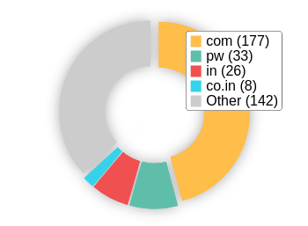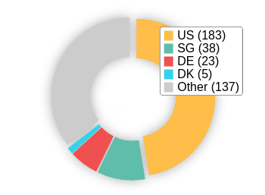Top TLDs Top Countries

## On-Page Link Structure

We found 21 total links. 10% of your links are external links and are sending authority to other sites. 0% of your links are nofollow links, meaning authority is not being passed to those destination pages.

## Friendly Links

Some of your link URLs do not appear friendly to humans or search engines.

We would recommend making URLs as readable as possible by reducing length, le names, code strings and special characters.

Usability

## Your usability could be better

Your page is OK but could be more usable across devices. Usability is important to maximize your available audience and minimize user bounce rates (which can indirectly a ect your search engine rankings).



**B**

## Device Rendering

This check visually demonstrates how your page renders on di erent devices. It is important that your page is optimized for mobile and tablet experiences as today the majority of web tra c comes from these sources.

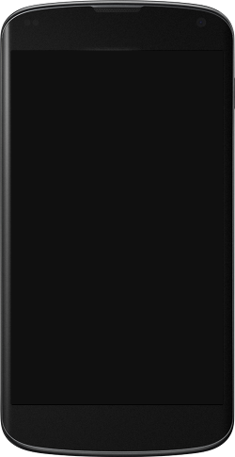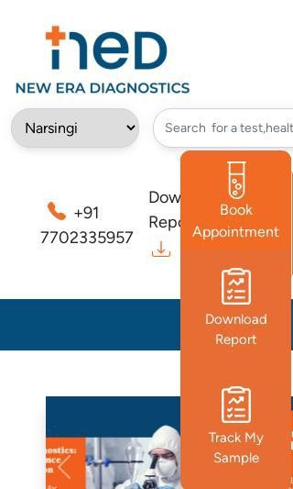

## Google's Core Web Vitals

Google is indicating that they do not have 'su cient real-world speed data for this page' in order to make a Core Web Vitals assessment. This can occur for smaller websites or those that are not crawl- able by Google.

## Use of Mobile Viewports

Your page speci es a viewport matching the device's size, allowing it to render appropriately across devices.

## Google's PageSpeed Insights - Mobile

Google is indicating that your page is scoring poorly on their Mobile PageSpeed Insights evaluation.

Note that this evaluation is being performed from US servers and the results may di er slightly from an evaluation carried out from Google's PageSpeed Web Interface as that reporting localizes to the region in which you are running the report.

Google has indicated that the performance of a webpage is becoming more important from a user and subsequently ranking perspective.



**71**

Lab Data Value

Speed Index

3.5 s

Time to Interactive

3.3 s

Total Blocking Time 0 s

Largest Contentful Paint 4.9 s

First Contentful Paint 3.3 s

Opportunities Estimated Savings

Serve images in next-gen

formats

5.23 s

E ciently encode images 2.73 s

Eliminate render-blocking

resources

2.29 s

Cumulative Layout Shift 0.128

Reduce unused CSS 0.23 s

Properly size images 0.23 s

## Google's PageSpeed Insights - Desktop

Google is indicating that your page is scoring well on their Desktop PageSpeed Insights evaluation.



**90**

Lab Data Value

Opportunities Estimated Savings

Speed Index

1 s

Time to Interactive

1 s

Total Blocking Time 0 s

Largest Contentful Paint 1.6 s

First Contentful Paint 1 s

Serve images in next-gen

formats

0.67 s

Eliminate render-blocking resources

E ciently encode images 0.38 s

0.63 s

Cumulative Layout Shift 0.133

## Flash Used?

No Flash content has been identi ed on your page.

## iFrames Used?

There are no iFrames detected on your page.

## Favicon

Your page has speci ed a favicon.

## Email Privacy

Email addresses have been found in plain text.

We recommend removing any plain text email addresses and replacing them with images or contact forms. Plain text email addresses can be susceptible to scrapers and email spammers.

## Legible Font Sizes

The text on your page appears to be legible across devices.

## Tap Target Sizing

The links and buttons on your page appear to be appropriately sized for a user to easily tap on a touchscreen.

Performance Results

## Your performance could be better

Your page's performance has some issues and room for improvement. Performance is important to ensure a good user experience, and reduced bounce rates (which can also indirectly a ect your search engine rankings). We recommend addressing the highlighted factors below.



**B+**

## Page Speed Info

Your page loads in a reasonable amount of time.

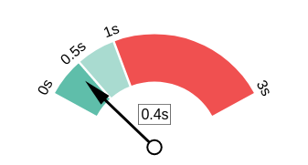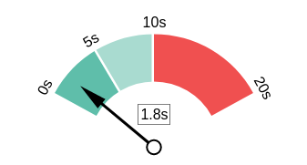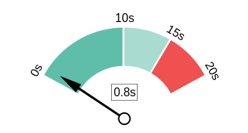Server Response All Page Content Loaded All Page Scripts Complete

## Download Page Size

Your page's le size is reasonably low which is good for Page Load Speed and user experience.

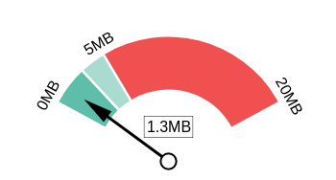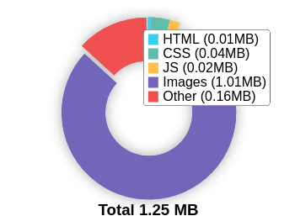Download Page Size Download Page Size Breakdown

## Website Compression (Gzip, Deflate, Brotli)

Your website appears to be using a reasonable level of compression.

Compression Rates Raw Page Size Breakdown

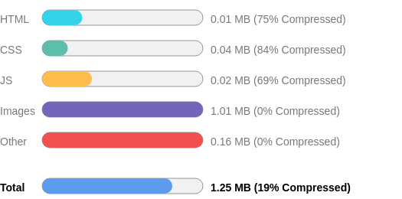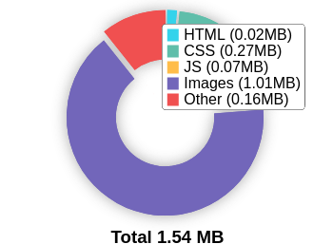

## Number of Resources

This check displays the total number of les that need to be retrieved from web servers to load your page.



26

Total Objects

1

Number of

HTML Pages

1

Number of JS

Resources

4

Number of CSS

Resources

17

Number of

Images

3

Other

Resources

## Google Accelerated Mobile Pages (AMP)

This page does not appear to have AMP Enabled.

## JavaScript Errors

Your page is not reporting any JavaScript errors.

## HTTP2 Usage

Your website is using an outdated HTTP protocol.

We recommend enabling HTTP/2+ or protocol for your website as it can signi cantly improve page load speed for users.

## Optimize Images

Your page appears to include images which are poorly optimized.

Properly formatting and compressing images can have a signi cant impact on page load performance.

## Minification

All your JavaScript and CSS les appear to be mini ed.

## Deprecated HTML

No deprecated HTML tags have been found within your page.

## Inline Styles

No inline styles have been found within your page's HTML tags.

Social Results

## Your social needs improvement

You appear to have a weak social presence or level of social activity (or we may just not be able to see your pro les!). Social activity is important for customer communication, brand awareness and as a marketing channel to bring visitors to your website. We recommend that you list all of your pro les on your page for visibility, and begin to build a following on those networks.



**F**

## Facebook Connected

No associated Facebook Page found as a link on your page.

## Facebook Open Graph Tags

We have not found Facebook Open Graph Tags on your page.

Facebook Open Graph Tags are a type of structured data that can be placed on your page to control what content is shown when a page is shared on Facebook.

## Facebook Pixel

We have not detected a Facebook Pixel on your page.

Facebook's Pixel is a useful piece of analytics code that allows you to retarget visitors if you decide to run Facebook Ads in future.

## Twitter Connected

No associated Twitter pro le found as a link on your page.

## Twitter Activity

No associated Twitter pro le found as a link on your page.

## Twitter Cards

We have not detected Twitter Cards on your page.

Twitter Cards are a type of structured data that can be placed on your page to control what content is shown when a page is shared on Twitter.

## Instagram Connected

No associated Instagram pro le found linked on your page

## LinkedIn Connected

No associated LinkedIn pro le found linked on your page.

## YouTube Connected

No associated YouTube channel found linked on your page.

## YouTube Activity

No associated YouTube channel found linked on your page.

Local SEO

## Local Business Schema

No Local Business Schema identi ed on the page.

## Google Business Profile Identified

A Google Business Pro le was identi ed that links to this website.



New Era Diagnostics ( NED), Suncity Branch

## Google Business Profile Completeness

The important business details are present on the Google Business Pro le.

Phone +91 91822 01954

Site https://neweradiagnostics.in/

Address Plot no.185, Jagir, beside Rao's School, Indra Reddy Nagar, Rajendra Nagar, Bandlaguda Jagir, Hyderabad, Telangana 500086

## Google Reviews

Your Google Business Pro le has a low rating or low number of reviews.

5.0

★★★★★

6 reviews

Rating

4

2

1

3

5

Technology Results

## Technology List

These software or coding libraries have been identi ed on your page.

Technology Version



jsDelivr

PHP 7.4.33

Bootstrap 5.0.2

## Server IP Address

135.181.211.87

**DNS Servers** dns2.bigrock.in dns4.bigrock.in

dns1.bigrock.in

dns3.bigrock.in

## Charset

text/html; charset=UTF-8



https://www.thepatternscompany.com/

**The Purpose of a Business is to create a Customer Who Creates Customer’s**

**Thank you**